JIS College of Engineering
(An Autonomous Institution)

Department of Computer Science and Engineering

UG Project Proposal’2014-2015

Title:

Novel approach of ear and face biometrics in surveillance system.

Abstract:

Biometric surveillance is any technology measures and analyzes human physical and/or behavioral characteristics for authentication, identification, or screening purposes. Identification is an essential part of our lives. Identification of authentic candidate is essential in E-commerce, in keeping track of criminals, in airport and railway surveillance and many more aspects of the modern world. However identification of a person can be challenging especially when the person is not cooperating. This leads to classify the identification techniques broadly in to two categories: Passive and Active. In this current study an approach has been proposed combining the ear and face biometrics for the purpose of identification of a person.

Most biometric system is unimodal (i.e. they use only one biometric sample to recognize a person). Even the best unimodal biometric system (usually iris, fingerprint and retina scanners) are far from perfect. They have many inherent problems in their use and no single biometric technology is perfectly suited for all applications. These unimodal technologies suffer from noisy sensor data, lack of individuality, non-universality, and spoof attacks.

It is logical to try and combine multiple biometric samples to get the best results. Some of the problems inherent in unimodal biometric systems can be overcome by using multiple sources of information. Such systems are knows as multimodal biometric system, which uses two or more biometric samples from the same person in order to identify the person.

In this current study an approach has been proposed to use an artificial intelligent system to extract the cropped images of the face and ear from the side view of the face. Since every person’s ear and side view have unique features. By taking advantage of this uniqueness a combined technique can be used to develop a system for the purpose of identification of a person.

After extracting the cropped images, they can be combined using “Alpha blending” technique to obtain a fused image. From this fused image features can be extracted using either Harris Corner detection or SIFT (Scale Invariant Feature Transform) or other technique. The extracted features can be stored in a database, which could be used later on for the purpose of matching.

- As the main application of this proposed approach is in surveillance system, an operational computer vision system for real-time detection and tracking of human motion could be combined with the proposed approach. As a result the system could search the archived video for classes of activity specified such as side face detection without the need for viewing of each sequence of surveillance video.


Figure 1 Side face

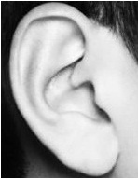  Figure 2 Ear | 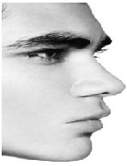  Figure 3 Side face

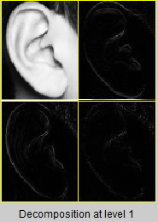 | 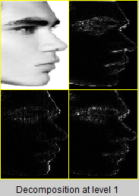

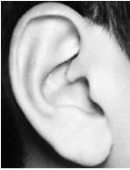  Figure 4 Synthesised image of ear | 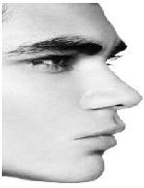  Figure 5 Synthesised image of side face

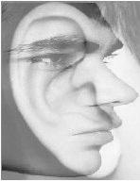
Figure 6 Fused image of ear and side face

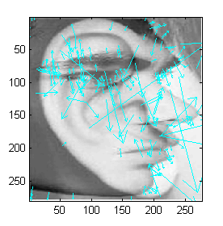
Figure 7 Extracted features using SIFT
MATCHING
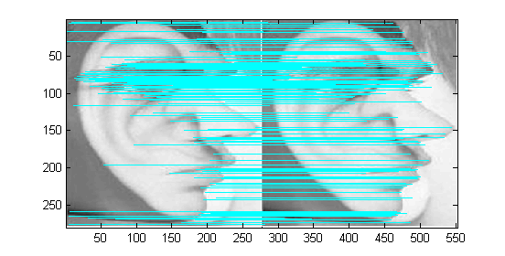
Figure 8 Normal matching

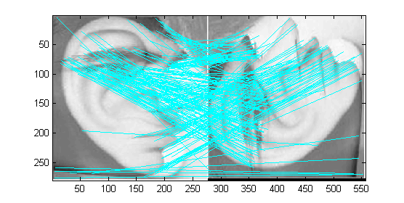
Figure 9 Image rotated by 90 degree
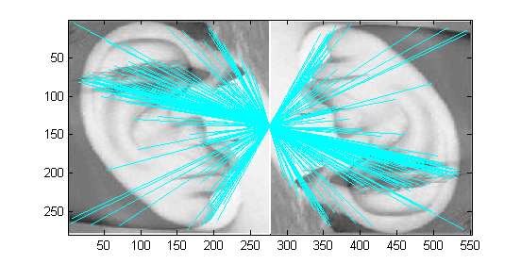
Figure 10 Image rotated by 180 degree

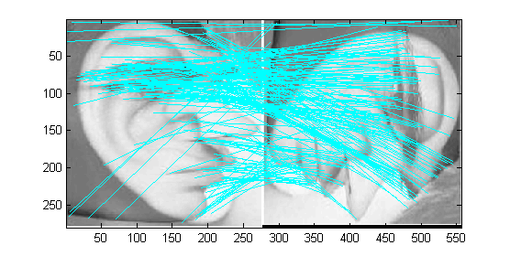
Figure 11 Image rotated by 270 degree

RESULTS

Number of key points found in the fused image is 206

Image Transformation | Match found
0 degree | 206
90 degree | 189
180 degree | 187
270 degree | 190

Candidate signature:

__________________
Mr. Akash Pal
VII SEM B.Tech CSE

__________________
Miss. Debolina Das
VII SEM B.Tech CSE

__________________
Mr. Sukanta Sharma
VII SEM B.Tech CSE

__________________
Mr. Avinandan Sau
VII SEM B.Tech CSE

Guide signature:

___________________
CSE Dept.

